


________________
jumps into a book




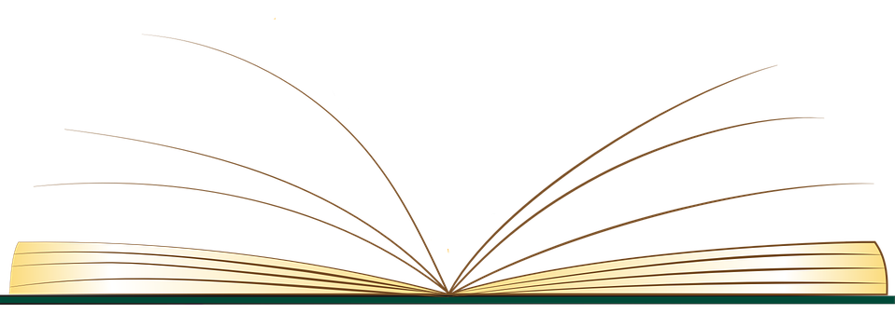

Aqra kemm Tiflaħ or call 25983304.




_____________’S READING DIARY

Date | Book | Did you like the book?  Choose a frog to show whether you liked the book or not. | Parent/Guardian Signature
Date | Book | Did you like it? | Parent Signature
Date | Book | Did you like it? | Parent Signature

Date | Book | Did you like it? | Parent Signature
Date | Book | Did you like it? | Parent Signature

